**Apigee (SaaS) Network Connectivity**

Contents

**1.** **Preamble:** 2

**2.** **Scope of Apigee deployment:** 2

**3.** **Out of Scope (Q2):** 2

**4.** **Current API management network architecture** 3

**5.** **Proposed HL API Management Network architecture** 3

**6.** **APIGEE Environments** 4

**7.** **Network Connectivity** 4

**8.** **Scenarios – Transaction flows** 6

**9.** **Backend Server details** 6

**10.** **API Platform Roadmap** 7

**11.** **SE Apigee Target Architecture (SaaS)** 8

**Author: Hirok Choudhury**

**Digital Architecture**

|  |  |  |
| --- | --- | --- |
| **Version & Date** | **Created/Changed by** | **Change details** |
| **1.0/ Apr 15, 2019** | **Hirok Choudhury** | **Initial version** |
| **1.1/Jul 10,2019** | **Hirok Choudhury** | **Added additional diagrams and backend server details and removed the application deployment related content.** |

# **Preamble:**

SE has signed an enterprise license agreement with Google for the Apigee API Management solution (effective from Jan 31st). The license covers provisioning of both SaaS and On-prem deployment of Apigee. This document only covers Apigee SaaS deployment for Schneider Electric. It is associated with DP2745 and SEACat id 50600.

The initial version of this document provided just enough information to agree on network connectivity and provide all required inputs to the platform certification process.

Apigee is an API Management Platform from Google. Check <https://docs.apigee.com>

Current IFW API Manager will be replaced by Google APIGEE (API Management).

# **Scope of Apigee deployment:**

* All modules of Apigee that are included in the Enterprise license agreement to be deployed across Dev, multiple test environments, preprod and Prod.
* SaaS implementation
* Identify & deploy across 5 regions for global coverage
* SAML integration through SE PING identity manager

# **Out of Scope (Q2):**

* On-premise Apigee deployment
* API design & delivery factory
* API Test & Analytics
* GitHub & CICD
* Production support

# **Current API management network architecture**

Its based on WSO2 API Manager technology. IFW (Integration framework) team is responsible for both API management (WSO2 API Manager) and Integration (WSO2 ESB). See the diagram below for details.

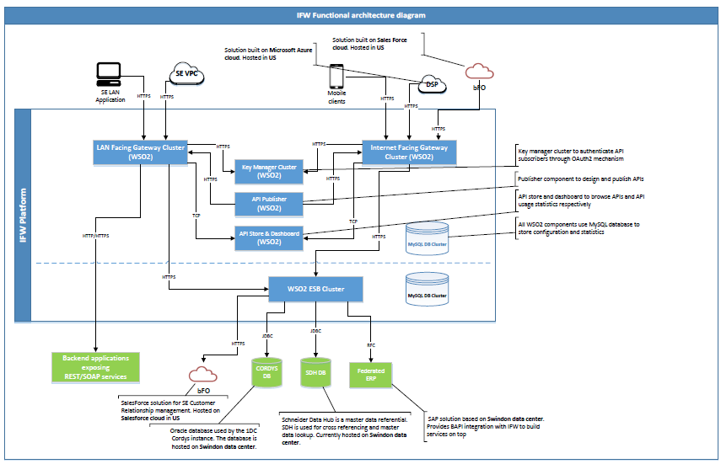

WSO2 Gateways are replaced by APIGEE

# **Proposed HL API Management Network architecture**

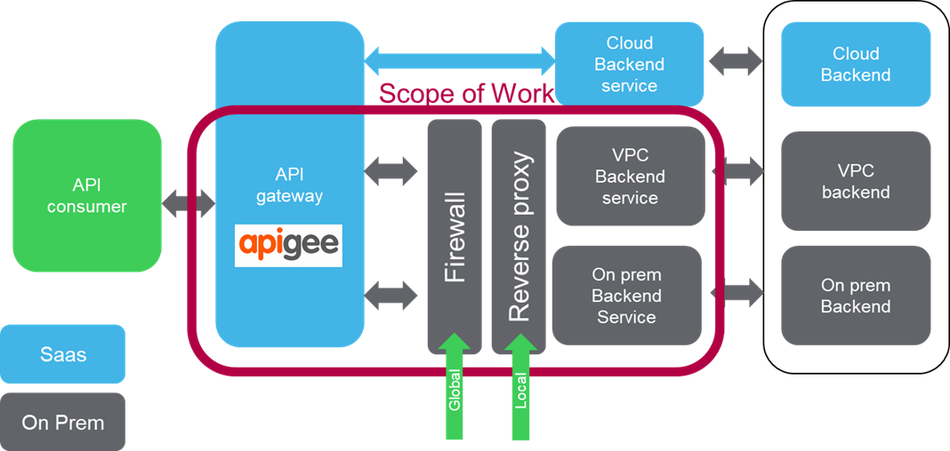

# **APIGEE Environments**

Below is the setup of Organizations and Environments for each:

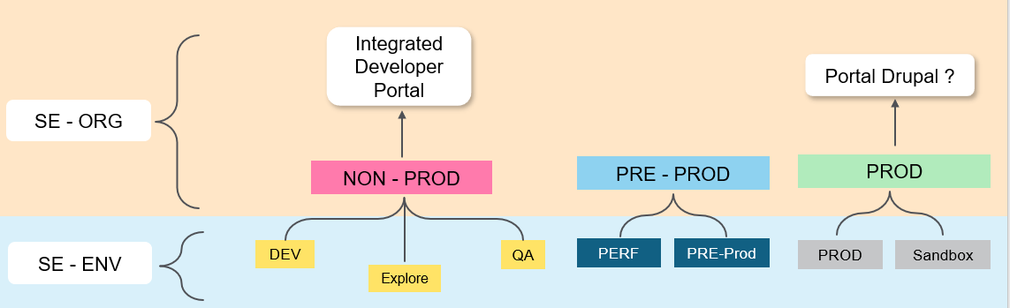

# **Network Connectivity**

For reference, sharing the SE network related information on our Cloud access Hubs and VPC’s. This information has been shared by Attila Czinkoczky from SE network team.

1. Main Schneider on-premise Datacenters
   * Montpellier, France
   * St Louis, MO
   * Singapore
2. Cloud datacenters (AWS nodes, see Diagram below)
   * SE nodes are the cloud access Hubs to reach AWS from the Schneider network
   * Please ignore the Azure footprint since not available yet.

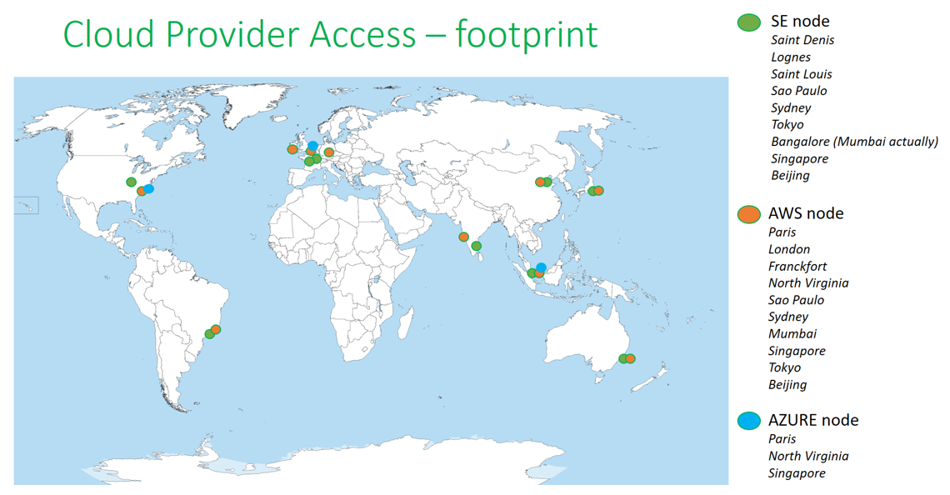

As per the contract, we can provision Apigee instances across 5 regions.

The IP addresses of the Apigee Dev/QA, Pre-Prod and Prod Environment are shared below:

|  |  |  |  |
| --- | --- | --- | --- |
| Regions | Non-Prod | Pre-Prod | Prod |
| US -Central | 104.154.58.87  35.188.85.27 | 35.188.85.27  104.154.58.87 | 104.197.220.187  35.239.206.63 |
| EU- Belgium | 34.76.95.254  35.233.21.248 | 34.76.95.254  35.233.21.248 | 104.199.6.159  35.195.167.80 |
| Brazil | 35.247.236.59  35.247.208.254 | 35.247.236.59  35.247.208.254 | 35.199.66.224  35.199.97.190 |
| Australia | 35.189.29.105  35.189.43.30 | 35.189.43.30  35.189.29.105 | 35.244.84.119  35.189.35.3 |
| Singapore | 35.240.241.208  34.87.49.46 | 35.240.241.208  34.87.49.46 | 35.240.203.200 35.240.147.167  35.186.150.178  35.198.242.145 |

For the GCP physical locations:

  US - Central:  Council Bluffs, Iowa

  EU-Belgium:  St Ghislain, Belgium

  AP-Singapore:  Singapore

  AP-Australia:  Sydney

  SA-Brazil:  São Paulo

Regarding BGP, Apigee uses its own VPCs within Google and does require peering.  Apigee benefits from Google's network (such as the [Global Load Balancers](https://eur02.safelinks.protection.outlook.com/?url=https%3A%2F%2Fcloud.google.com%2Fload-balancing%2F&data=02%7C01%7CHirok.Choudhury%40se.com%7Ca6817a744c7242da993808d6b7890421%7C6e51e1adc54b4b39b5980ffe9ae68fef%7C0%7C0%7C636898196434502750&sdata=iTyOPjuvtRZI%2F0lqhk5iJkABjJRwtW9l1leXwKgiliY%3D&reserved=0)) to find the most efficient route to the nearest Apigee region.

We came to know that except St Louis data center, all other data centers are managed by Vendors- IBM, Capgemini,EPAM, etc..

**N/w Testing:** On 4/4/2019 A Network testing has been started working with Eric D. to confirm that traffic flows to the correct instance of Apigee (on GCP). The test has been successful.

# **Scenarios – Transaction flows**

There are two distinct flows: **Internal** (traffic originated from within SE network) and **external** (traffic coming from Internet). Two illustrate the flows for internal we will use mySE as an example and for the external flow we will use bFO (SFDC).

**External Flow: bFO**





**Internal Flow: mySE**





# **Backend Server details**

Apigee endpoint: api.se.com (Prod).

|  |  |  |  |  |  |  |  |  |
| --- | --- | --- | --- | --- | --- | --- | --- | --- |
| backend  APIGEE | Dev | FT | INT | UAT | Perf | Pre-Prod | Prod | Notes |
| Explore | X |  |  |  |  |  |  |  |
| Dev | X | X | X |  |  |  |  |  |
| QA |  |  |  | X |  |  |  |  |
| Perf |  |  |  |  | X |  |  |  |
| Pre-prod |  |  |  |  |  | X |  |  |
| Prod |  |  |  |  |  |  | X |  |
| Sandbox |  |  |  |  |  | X |  | Dedicated for ‘Try IT’ from Portal |

Within APIGEE three Organizations (logical grouping) defined. Non-Prod houses Explore, Dev and QA. Pre-prod houses Perf and Pre-prod and finally Prod organization has two environments viz. Prod and Sandbox.

# **API Platform Roadmap**

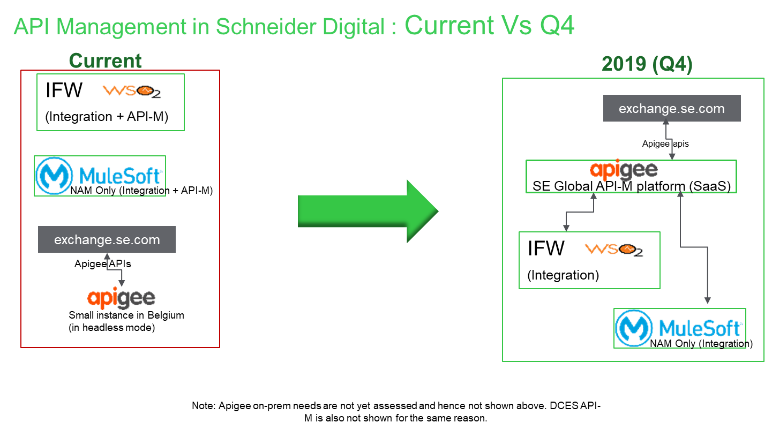

Current = = End of Q1 (Mar’2019).

The roadmap below shows the Epics (in agile terminology) spread across four quarters in 2019. This document covers the plan for the scope of ‘Apigee Deployed’ under Q2 for API Management stream.

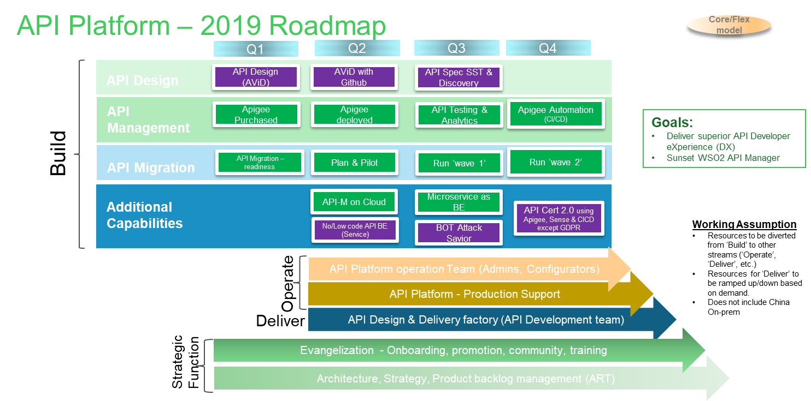

# **SE Apigee Target Architecture (SaaS)**

The architecture is defined keeping SE global SaaS requirements in mind. This is to enable one common platform to expose APIs safely, deliver with speed and operate at scale using consistent policies & practices.

